Machine Learning is creating tremendous economic value today. 99 Percent of the economic value created by Machine Learning today is through one type of Machine Learning, which is called Supervised Learning. Supervised Learning refers to algorithms that learn X to Y or input to output mappings.

The key characteristic of Supervised Learning is that you give your learning algorithm examples to learn from that includes the right answers, whereby right answer, the correct label Y for a given input X, and is by seeing correct pairs of input X and desired output label Y that the learning algorithm eventually learns to take just the input alone without the output label and gives a reasonably accurate prediction or guess of the output. Below are the examples of Supervised Learnings:

|  |  |  |
| --- | --- | --- |
| **Input (X)** | **Output (Y)** | **Application** |
| Email | Spam? (0/1) | Spam Filtering |
| Audio | Text Transcripts | Speech Recognition |
| English | Spanish | Machine Translation |
| Ad, User Info | Click? (0/1) | Online Advertising |
| Image, Radar Info | Position of other cars | Self-driving Car |
| Image of Phone | Defect? (0/1) | Visual Inspection |

In all of these applications, you will first train your model with examples of input X and the right answers Y. After the model has learned from these Input and Output or X and Y pairs, they can then take a brand new input X, something it has never seen before and try to produce the appropriate corresponding output Y. Let’s dive more deeply into one specific example:

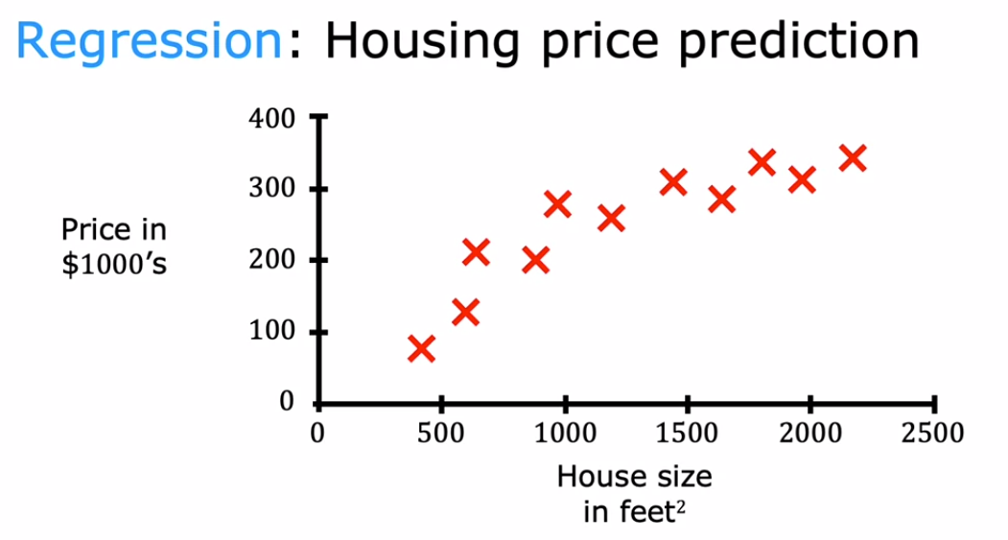

Say you want to predict housing prices based on the size of the house. You’ve collected some data and say you plot the data and it looks like above. On the horizontal axis, is the size of the house in square feet. On the vertical axis is the price of the house in, thousands of dollars.

With this data, let’s say a friend wants to know what’s the price for their 750 square foot house. How can the learning algorithm help you?

One thing a learning algorithm might be able to do is say, for the straight line to the data and reading off the straight line, it looks like your friend’s house could be sold for about $150,000. But fitting a straight line isn’t the only learning algorithm you can use. There are others that could work better for this application.

For example, routed and fitting a straight line, you might decide that it’s better to fit a curve, a function that’s slightly more complicated or more complex than a straight line. If you do that and make a prediction here, then it looks like your friend’s house could be sold for closer to $200,000.

This is the example of Supervised Learning because we gave the algorithm a dataset in which the so-called right answer, label Y is given for every house on the plot. The task of the learning algorithm is to produce more of these right answers, specifically predicting what is the likely price for other houses like your friend’s house.

That’s why this is Supervised Learning. To define a little more terminology, this housing price prediction is the particular type of Supervised Learning called regression. From regression, we are trying to predict a number from infinitely many possible numbers.